WORKSHEET AIR TRAVEL
- Answer the questions
- Have you ever travelled by plane?
- What are the advantages and disadvantages of travelling by plane?
- When did you last travel by plane? Tell me more about it.
- Would you like to work as a flight attendant? Why/Why not?
- What part of the flight do you enjoy/dislike most?

- Match the following words with their correct definition:
- Long-haul
- Baggage reclaim
- Jet lag
- Baggage allowance
- Hold luggage
- Aisle
- Arrival concourse
- Trolley
a) the amount of checked baggage or hand/carry-on luggage the company will allow per passenger
b) travelling a long distance, usually by plane
c) the felling of being tired after flying
d) the area where arriving passengers collect luggage that has been transported in the hold of the aircraft
e) a large metal basket or frame on wheels, used for transporting heavy or large items
f) a passage between rows of seats
g) luggage that you check in (luggage to go "in the hold")
h) a large space or room in a public building such as an airport, which people gather in or pass through

- If a business traveller is departing from an international airport, he or she has to go through departing procedures. Put the procedures in the correct order. If you are not sure, check the internet, e.g. Boarding Procedures | At the Airport | Travel Information | ANA .
BOARDING GATE ONLINE CHECK-IN SECURITY
CHECK-IN BAGGAGE CHECK-IN IMMIGRATION

- Read the sentence below, translate the words you do not understand and explain the passage in your own words. Explain why the usage of the present perfect continuous tense. What information does it tell us about the process?
Thanks to pandemic and new technologies air travel has been going through digital transformation.

………………………………………………………………………………………………………………………………………………………………………………………………………………………………………………………………………………………………………………………………………………………………………………………………………………………………………………………………………………………………………………………………

- Picture descriptions and comparison
- Look at the pictures and make sure that you know the vocabulary to describe the pictures. If not, use dictionaries and the vocabulary help below.
- Note down two similarities and two differences between the pictures.
- Don´t forget to use the ´linking words and phrases´ to make your speech coherent.
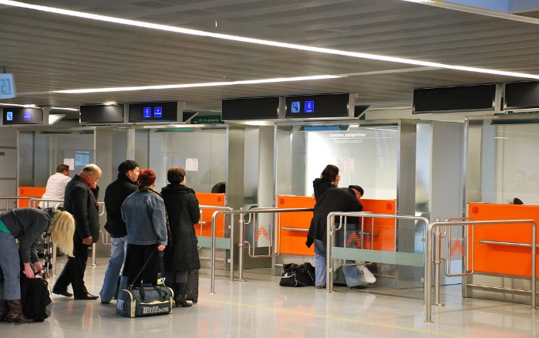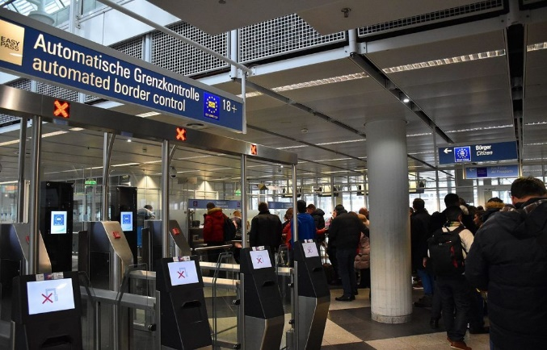
B
A

Vocabulary help:
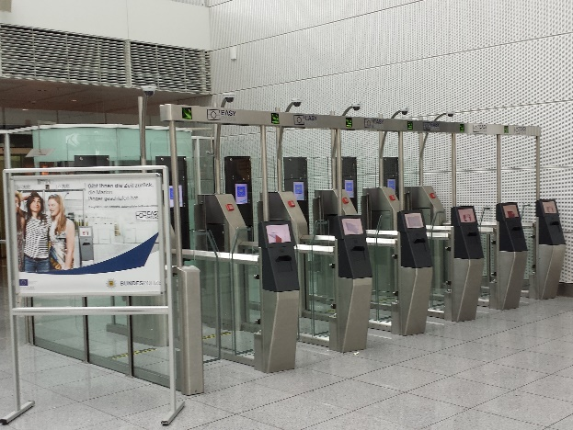 Automated border control systems (ABC) or eGates are automated self-service barriers which use data stored in a chip in biometric passports along with a photo or fingerprint taken at the time of entering the eGates to verify the passport holder's identity. Travellers undergo biometric verification using facial or iris recognition, fingerprints, or a combination of modalities.

By EasyPASS MUC.jpg: Bis gleich am Teich! Devilfighter_dederivative work: Bonus bon - This file was derived from: EasyPASS MUC.jpg:, CC BY-SA 3.0 de, https://commons.wikimedia.org/w/index.php?curid=89233083

